11.1>>FIRST IN FIRST OUT
PROGRAM CODE
#include <stdio.h>
int main()
{
int incomingStream[] = {7, 5, 9, 4, 3, 7, 9, 6, 2, 1};
int pageFaults = 0;
int frames = 3;
int m, n, s, pages;
pages = sizeof(incomingStream)/sizeof(incomingStream[0]);
printf("Incoming \t\t Frame 1 \t\t Frame 2 \t\t Frame 3");
int temp[ frames ];
for(m = 0; m < frames; m++)
{
temp[m] = -1;
}
for(m = 0; m < pages; m++)
{
s = 0;
for(n = 0; n < frames; n++)
{
if(incomingStream[m] == temp[n])
{
s++;
pageFaults--;
}
}
pageFaults++;
if((pageFaults <= frames) && (s == 0))
{
temp[m] = incomingStream[m];
}
else if(s == 0)
{
temp[(pageFaults - 1) % frames] = incomingStream[m];
}
printf("\n");
printf("%d\t\t\t",incomingStream[m]);
for(n = 0; n < frames; n++)
{
if(temp[n] != -1)
printf(" %d\t\t\t", temp[n]);
else
printf(" - \t\t\t");
}
}
printf("\nTotal Page Faults = %d\n", pageFaults);
return 0;
}
OUTPUT
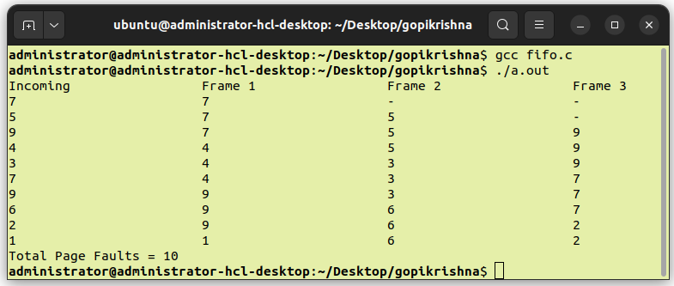

11.2>>LEAST RECENTLY USED
PROGRAM CODE
#include<stdio.h>
int main()
{
int nf,np,pages[100],frames[10],count[10],flag,min,next=0,i,j,k,fault=0;
printf("Number Of Frames = ");
scanf("%d",&nf);
printf("Number Of Pages = ");
scanf("%d",&np);
printf("Pages >> ");
for(i=0;i<np;i++){
scanf("%d",&pages[i]);
}
for(i=0;i<nf;i++){
count[i]=0;
frames[i]=-1;
}
for(i=0;i<np;i++){
flag=0;
for(j=0;j<nf;j++){
if(frames[j]==pages[i]){
flag=1;
count[j]=next;
next++;
}
}
if(flag==0){
if(i<nf){
frames[i]=pages[i];
count[i]=next;
next++;
}
else{
min=0;
for(j=1;j<nf;j++)
if(count[min]>count[j])
min=j;
frames[min]=pages[i];
count[min]=next;
next++;
}
fault++;
}
for(j=0;j<nf;j++){
printf("%d\t",frames[j]);
}
if(flag==0)
printf("PF no = %d",fault);
printf("\n");
}
printf("Page Fault = %d\n",fault);
return 0;
}
OUTPUT
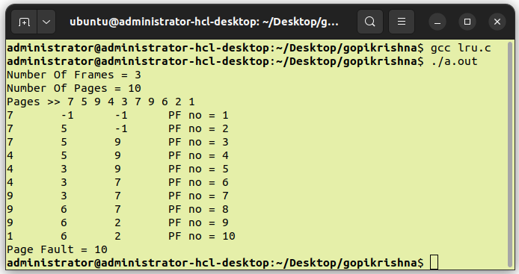

11.3>>LEAST FREQUENTLY USED
PROGRAM CODE
#include<stdio.h>
void print(int frameno,int frame[])
{
int j;
for(j=0;j<frameno;j++)
printf("%d\t",frame[j]);
printf("\n");
}
int main()
{
int i,j,k,n,page[50],frameno,frame[10],move=0,flag,count=0,count1[10]={0},
repindex,leastcount;
float rate;
printf("Number Of Pages = ");
scanf("%d",&n);
printf("Page Reference Numbers >> ");
for(i=0;i<n;i++)
scanf("%d",&page[i]);
printf("Number Of Frames = ");
scanf("%d",&frameno);
for(i=0;i<frameno;i++)
frame[i]=-1;
printf("Page Reference String\tFrames\n");
for(i=0;i<n;i++)
{
printf("%d\t\t\t",page[i]);
flag=0;
for(j=0;j<frameno;j++)
{
if(page[i]==frame[j])
{
flag=1;
count1[j]++;
printf("No Replacement\n");
break;
}
}
if(flag==0&&count<frameno)
{
frame[move]=page[i];
count1[move]=1;
move=(move+1)%frameno;
count++;
print(frameno,frame);
}
else if(flag==0)
{
repindex=0;
leastcount=count1[0];
for(j=1;j<frameno;j++)
{
if(count1[j]<leastcount)
{
repindex=j;
leastcount=count1[j];
}
}
frame[repindex]=page[i];
count1[repindex]=1;
count++;
print(frameno,frame);
}
}
rate=(float)count/(float)n;
printf("Number Of Page Faults = %d\n",count);
printf("Fault Rate = %f\n",rate);
return 0;
}
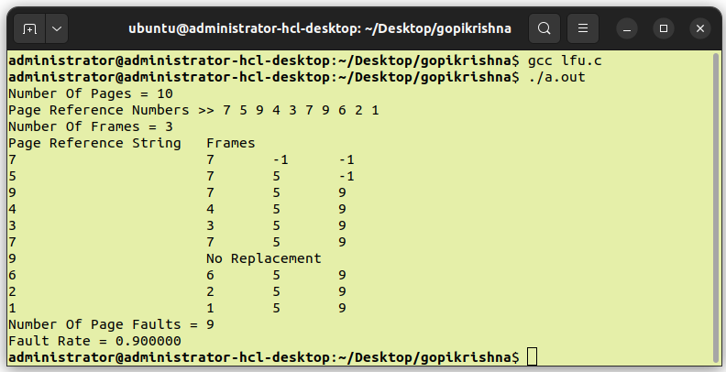
OUTPUT

